Pokhara University

Level: Bachelor | Semester – Fall | Year : 2011
Programme: BE |  | Full Marks: 100
Course: Filter Design |  | Pass Marks: 45
 |  | Time : 3hrs.

Candidates are required to give their answers in their own words as far as practicable.
The figures in the margin indicate full marks.

Attempt all the questions.

 | - Define filter. Illustrate different types of the filters according to their frequency responses in terms of both gain and attenuation.  - Design a first order passive high pass filter such that its dc gain T ( 0 ) = 0.3 and that gain at high frequencies is equal to T () = 1. The filter must have zero on the negative real axis at f_{z} = - 159 Hz. Plot the magnitude and phase of the filter. | 7  8
 | - Find the order of the Butterworth filter for the following lowpass filter specification:  - the loss in the passband to 15.92 Hz should not exceed 0.1 dB.  - beyond 318.31 Hz the loss is to be at least 20 dB.  - show the pole zero location and determine transfer function.  - Explain the Chebyshev low pass approximation method in filter design? How it is different from the Inverse Chebyshev approximation? | 8  [[  7
 | - What is the importance of frequency transformation in filter design? Explain how low pass filter can be transformed into high pass filter.  - Realize a third- order Butterworth low pass filter from LC ladder with unequal terminations R₁= 1Ω and R₂ = 4Ω.  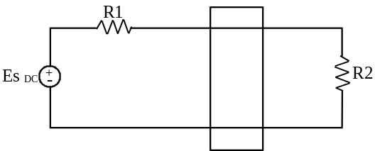 | 7  8
 | - Realize the transfer function corresponding to the bode plot by using op-amps given below.  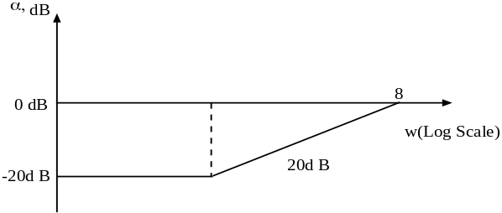  4  - Draw the circuit diagram for Sallen and Key circuit and derive its transfer function. | 8  7
 | - Define the term sensitivity? Perform sensitivity analysis for Tow Thomos Biquad Circuit.  - What is significance of FDNR? Simulate the 4th order Butterworth filter with the use of FDNRs such that its cut- off frequency is at 1000 Hz and also use 0.01μF capacitor only.  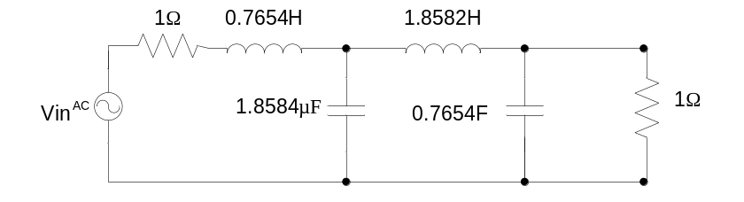 | 8  7
 | - Design a switched capacitor filter to realize the requirements of filter below:  |T(jw)|, dB  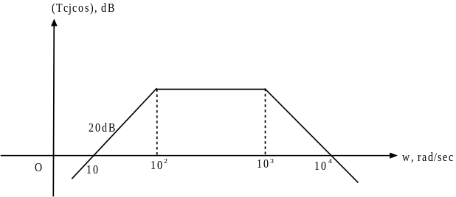  - Compare Butterworth Response and Chebyshev Response with suitable example. | 8  7
 | Write short notes on any two:  - High order filter design procedure  - Delay equalization  - RC-CR Transformation | 2×5

